Library
Central Library
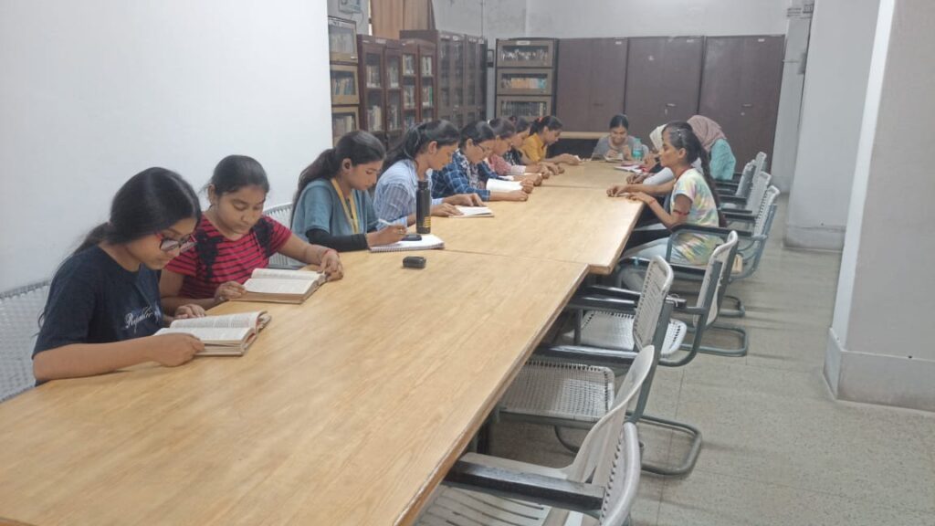
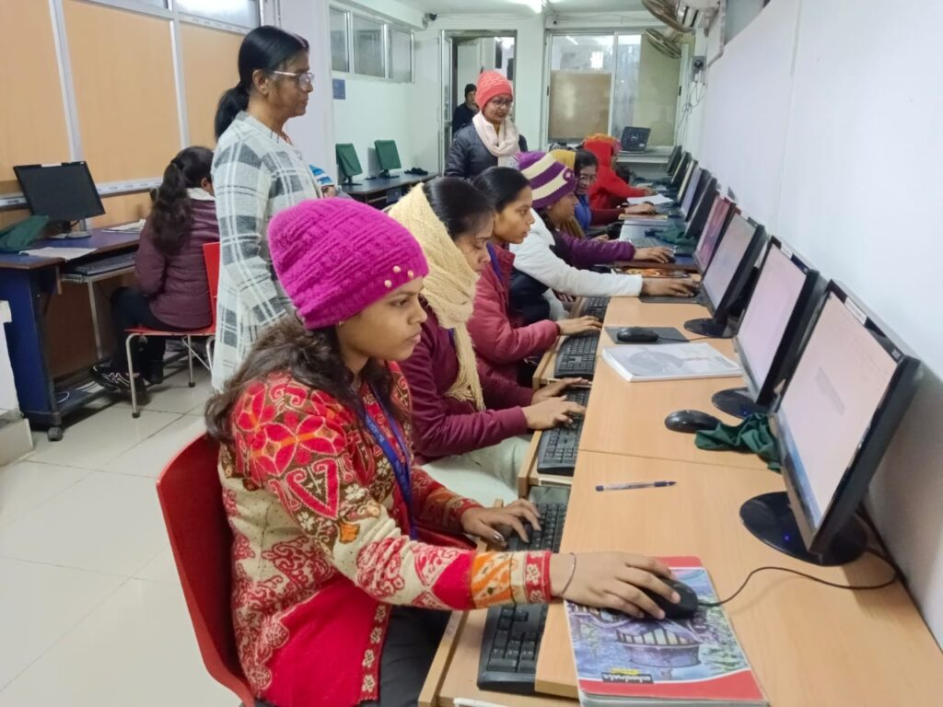
LIBRARY INCHARGE: Dr. Rishu Raj (Asst. Professor, Department of Political Science)
Assistant Library Incharge : Dr. Bhawana Singh (Asst. Professor (Guest Faculty), Department of History)
- Year of establishment : 1946
- Shifted in New Building : 1990
PARTICULARS
Books | Number Of Books
Books in Central Library | 1,55,643
Central Library Journals/ Periodicals/Magazines | 13
Central library Newspapers | 05
Books in B.Com. & BBA Library | 4821
Books in BCA Library | 4864
BCA e-books | 256
BCA e-journal | 01
Books in BSW Library | 381
Books in Library Economics PG | 1147
Books in Departmental Libraries | 5005
 | Total — 1, 72006
E-Resources :
- E-ShodhSindhu
- Shodhganga
- Sodh Gagotri
- OPAC – E-Granthalaya
- Library Admin / Staff Login E-Granthalaya
- Access Library Visitors page for Making Attendance
- N-List (Inflibnet)
- National Digital Library
LIBRARY STAFF
Sl No. | Name | Qualification | Post
1. | Ragini Kumari | M.Lib. & Info. Sc. , M.A (Philosophy), DCA, e-Library | Librarian
2. | Moni Kumari | B.Lib. & Info. Sc. , B.A (Political Sc. Hons) DCA | Library Assistant
3. | Moina Khatoon | Non Matriculation | Class IV
LIBRARY TIMING:
Library remains open from 9.30 am. to 4.30 PMon all working days.
LIBRARY MEMBERSHIP :
Magadh Mahila College library has an academic library to meet the need of the students and teaching staff of the college. The new members in 2017 are 1,486 students of which 322 are vocational and 1,164 are from the general section.
HIGHLIGHTS OF LIBRARY :
- e-libraryServices : The library has an open and fullyautomated accession system and lease line facility with the 100 Mbps internet connection to search any kind of books and journal very quickly. The library has installed KOHA software from INFLIBNET(Information and Library Network)
- Library card holder Students, Teaching and Non-teaching Staff are allowed internet surfing for downloading studymaterial.
- Students are using OPAC forsearching Books
- CIRCULATION SERVICES : The Issue counter, from where the users can issue 3 General books and B.A, B.Sc. and PG Students can issue 2 additional T.B.L. books at a time for a 15th day through Library Automation Software (KOHA) and Return on Return Counter.
- THE TECHNICAL SERVICES : The Technical section of the library provides classification and cataloguing services.
- REFERENCE SERVICES : The Central Library has a spacious Reading Room with a seating capacity of 105.
- JOURNAL/ MAGAZINES SERVICES : The library has Journal/ national Journals and Local Magazines. Employment News, English and Hindi Newspapers are also available.
- BINDING SERVICES : The library has binding section where previous years Journals and Magazines are covered. If further conservation of the book is required then binding section fulfilsit.
- XEROX SERVICES : The Library has Xerox section where students and Staffcan take the Xeroxcopy of Books, Magazines and Documents. Printing facilities are available after payment in special cases.
- SEPARATE COMPUTER WITH ADEQUATE SOFTWARE FOR VISUALLY CHALLENGED STUDENT.
LIBRARY OFFICIALS
Name and Designation
Dr. Rishu Raj
Library Incharge
Email
nawanisrcc@gmail.com
Ms. Ragini Kumari
Librarian (Officiating)
Professional Assistant
All the bonafide students of MMC, teaching, non-teaching staff members have right to access the College Library. To become a member of library, bonafide students should fill a form available with the Library Office. The registered members are issued Library Card corresponding to their entitlement. The Library members have following entitlements:
ISSUE OF BOOKS
CATEGORY OF MEMBERS | NO. OF BOOKS ENTITLED
Post Graduate Students | 4
Undergraduate Students | 4
Faculty members | 5 – 10
Non-teaching staff | 5
GAURAV RAJ GUPTA
Professional Assistant
gauravraj.gupta@srcc.du.ac.in
RULES & REGULATIONS

